GRADE 7 ACCELERATED · UNIT 2 · LESSON 6  Plotting, Ordering and Comparing Real Numbers  Circuit 7A.02.06 | Name_________________________  Date__________________________  Period________________________

Work the four parts in order, on your own. Everything here is from Lessons 1 through 5. This is the last practice before the unit assessment.
PART 1. Comparing
Use <, > or =. One of the six is an equality.
1. | 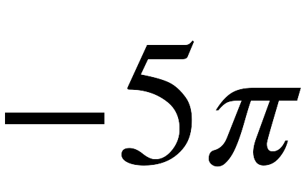 |  | 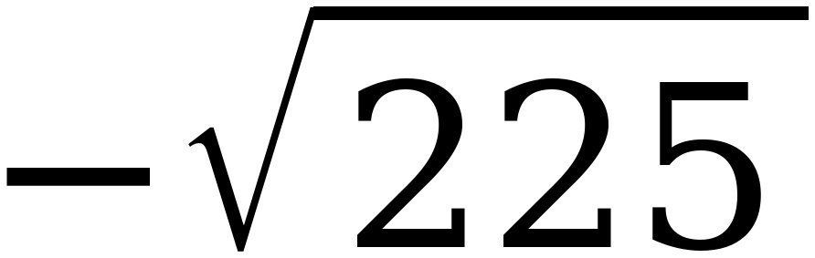
2. | 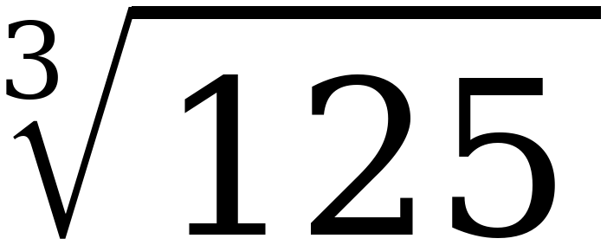 |  | 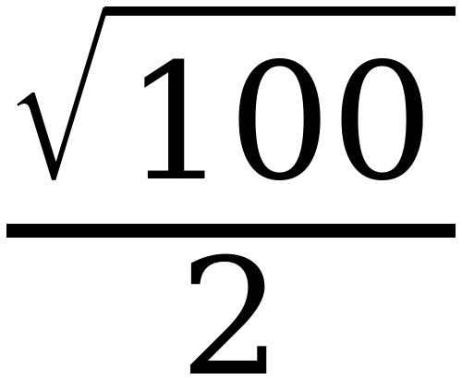
3. | 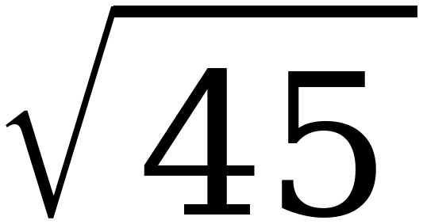 |  | 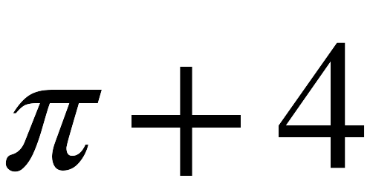
4. | −7 |  | 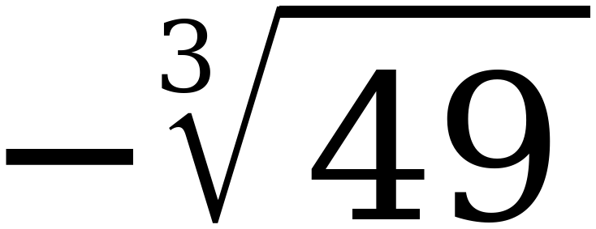
5. | 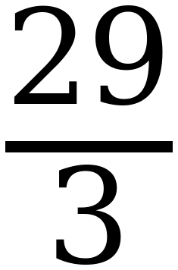 |  | 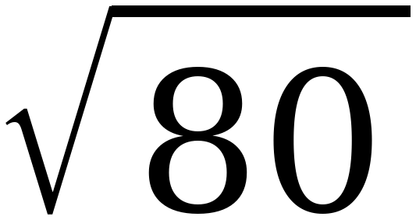
6. | 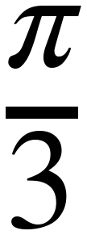 |  | 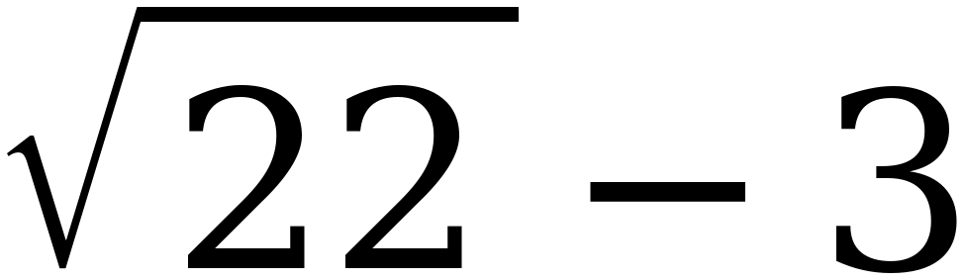

PART 2. Sorting and plotting
A number is irrational only if it cannot be written as a ratio of two integers.
7. Sort the five expressions, then plot and label each one on the number line.
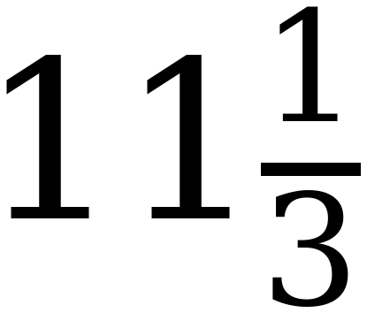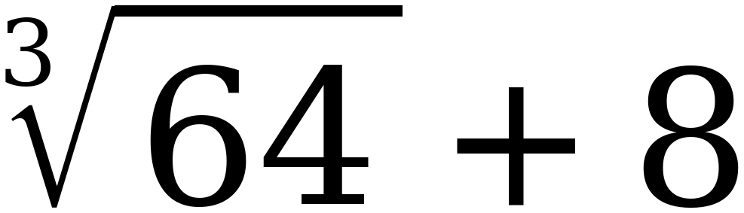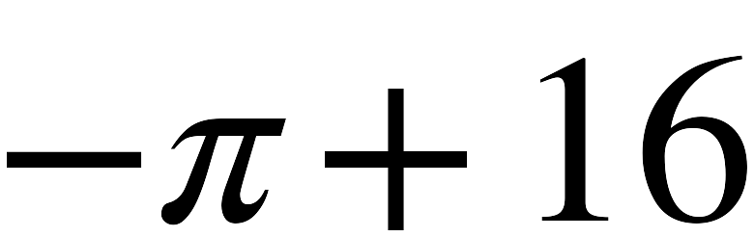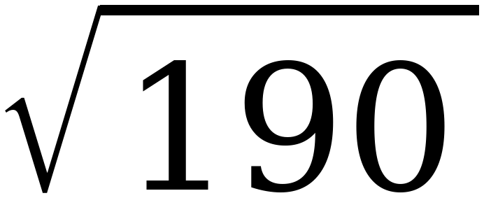
Only rational numbers | Includes an irrational number

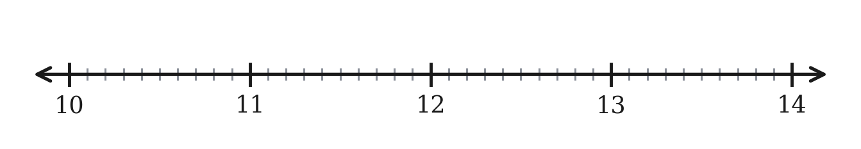
8. Plot and label each expression on the number line.
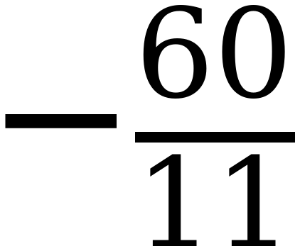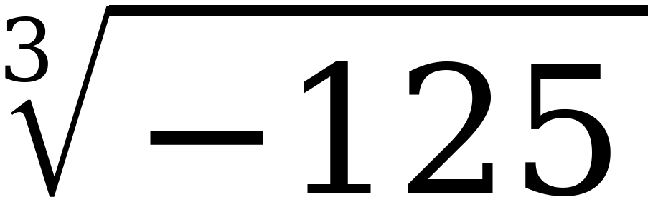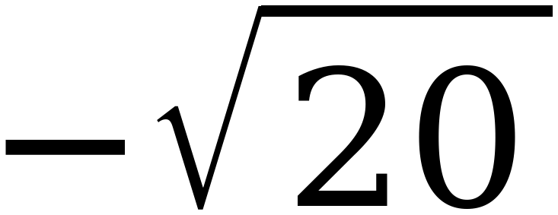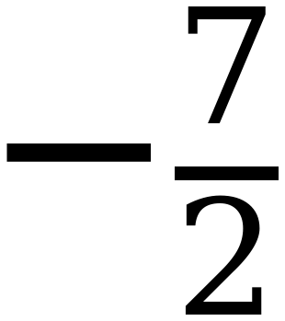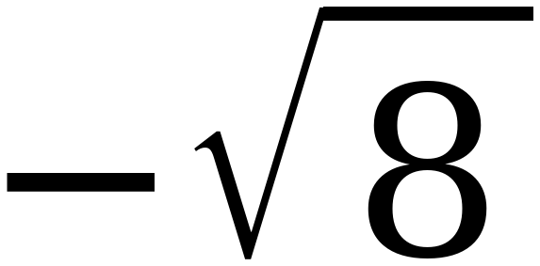
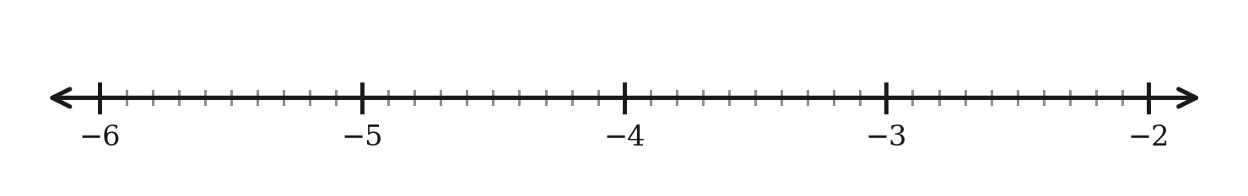
PART 3. Error analysis
Read the work, find the error, then do it correctly.
9. Sara approximated 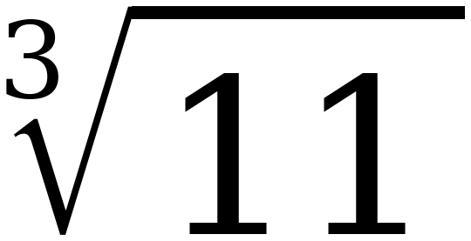 like this:
“11 is between 9 and 16, which are both perfect squares. So lies between 3 and 4, and it is closer to 3 because 11 is closer to 9 than to 16.”
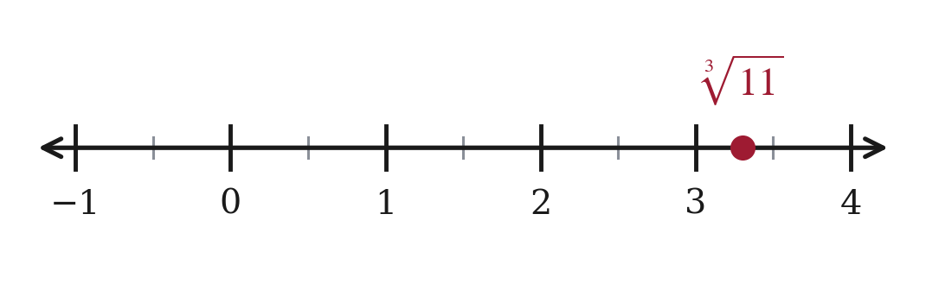
a. What is Sara's error?

b. Redo it correctly, then plot the right value.

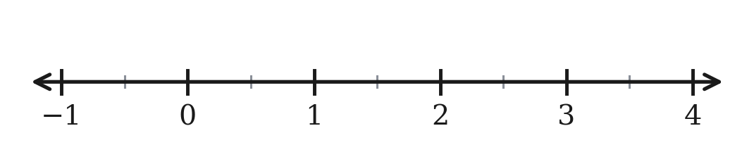
PART 4. Ordering and plotting
10. Order the numbers from least to greatest, then plot and label each one.
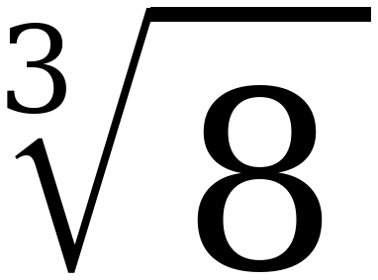 π 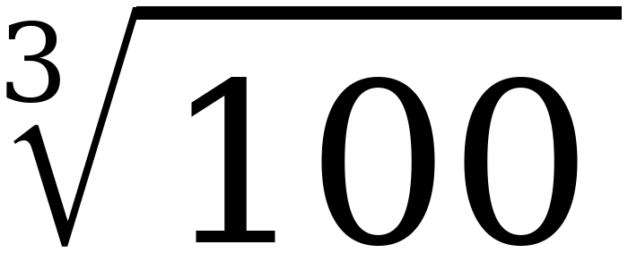 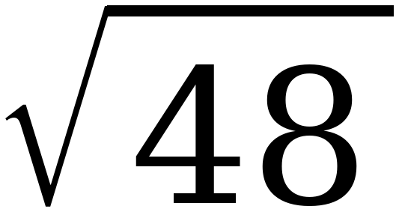 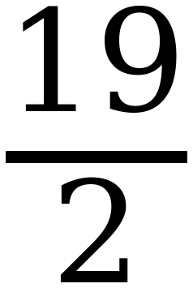 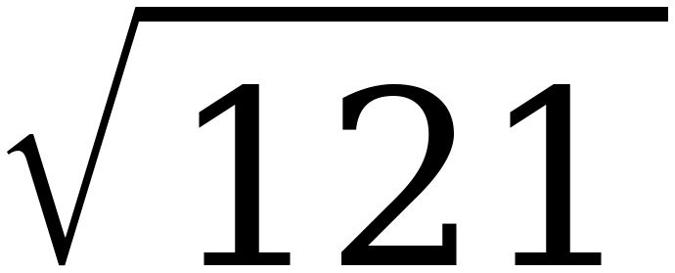

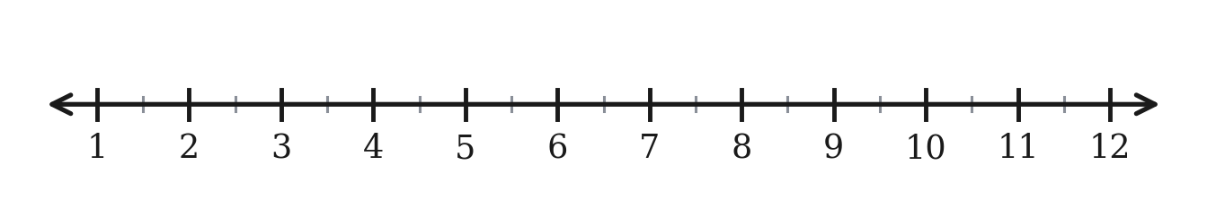
11. Order the numbers from least to greatest, then plot and label each one.
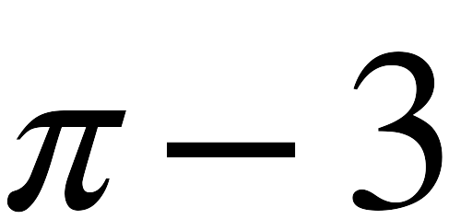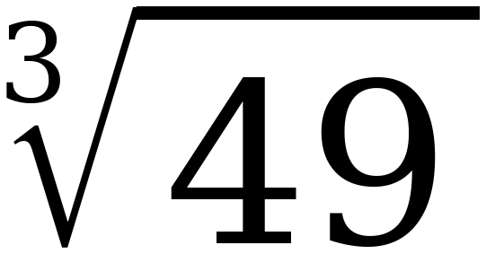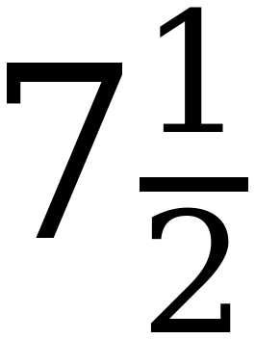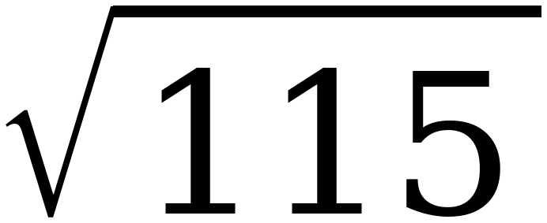

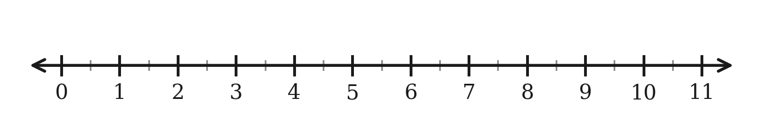
STRETCH. Beyond the range the test uses. Same method, bigger cubes.
12. Find the value of 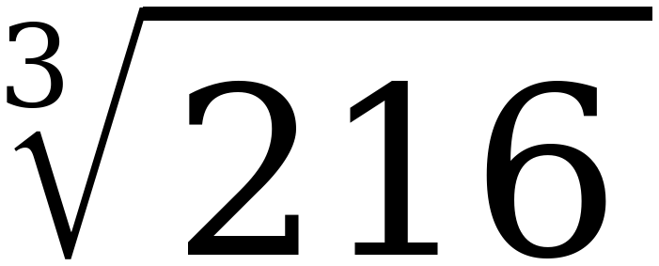 and of 

